**ACKNOWLEDGEMENT**

It is our pleasure to acknowledge the supervision of our project guide for their enormous help and guidance towards the Successful completion of “SCISSOR LIFTING MACHINE” The project we have undertaken. We are also reciprocation in full measure and kindness shown By *Mr. Tapan Kumar Chatterjee* (HOD of Mechanical & Automobile Engineering Department) & our (Mechanical lecturer*) S.KD AND R.N* sir. We are highly grateful to the faculty member and the staff of *Elite Polytechnic Institute.* Without their kind helps and guidance this project would not have been successful.

|  |  |  |  |
| --- | --- | --- | --- |
| SERIAL NO. | NAME | ROLL NO. | SIGNATURE |
| 1 | CHANDAN PAN | 61 |  |
| 2 | GOURANGA MALAKAR | 62 |  |
| 3 | SANJAY SARKAR | 63 |  |
| 4 | RAJDIP MALIK | 64 |  |
| 5 | RAKESH DAS | 65 |  |
| 6 | SUMAN GHORUI | 66 |  |
| 7 | SAIKAT DAS | 67 |  |
| 8 | ALAPAN DAS | 68 |  |
| 9 | ASIF ALI MOLLAH | 69 |  |
| 10 | AGNIDIPAN DEY | 70 |  |
| 11 | SUBHRADIP MONDAL | 71 |  |
| 12 | ARGHA BISWAS | 72 |  |
| 13 | BISHWANATH HEMBROM | 73 |  |
| 14 | ARPANDEB BANERJEE | 74 |  |
| 15 | SOUVIK BANERJEE | 75 |  |

GROUP MEMBERS

College: Elite Polytechnic Institute

**CERTIFICATE**

This is to certify this project on “SCISSOR LIFTING MACHINE” work done by [[ CHANDAN PAN (roll:61) ,GOURANGA MALAKAR (roll:62), SANJAY SARKAR (roll:63), RAJDIP MALIK (roll:64), RAKESH DAS (roll:65), SUMAN GHORUI (roll:66), SAIKAT DAS (roll:67), ALAPAN DAS (roll:68), ASIF ALI MOLLAH (roll:69), AGNIDIPAN DEY (roll:70), SUBHRADIP MONDAL (roll:71), ARGHA BISWAS (roll:72), BISHWANATH HEMBROM (roll:73), ARPANDEB BANERJEE (roll:74), SOUVIK BANERJEE (roll:75) ]] students of MECHANICAL ENGINEERING DEPERTMENT, 3RD YEAR of ELITE POLYTECHNIC INSTITUTE , MOGRA. That had carried out the project under our supervision and guidance.

**APPROVED BY:-**

:-

Sign …………………………………………….

(SDFGHJKHGYJN FHHNJNH)

(Signature of Principle)

Sign ……………………………………………

(TAPAN KUMAR CHATTERJEE)

(Signature of H.O.D)

Sign ……………………………………………

(SAJAL KANTI DAS)

(Signature of guidance Teacher 1)

Sign ……………………………………………..

NAME OF EXTERNAL EXAMINER

Sign ……………………………………………

(RABINDRANATH NANDI)

(Signature of guidance Teacher 2)

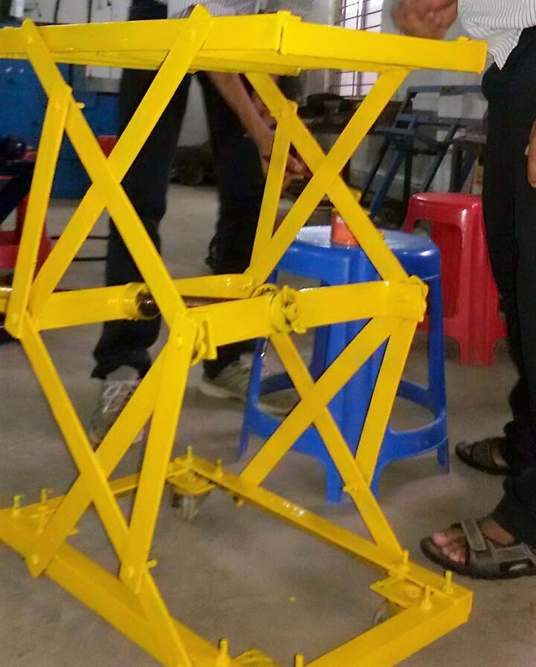

**PREFACE**

A **scissor lift** is a type of platform that can usually only move vertically.  The mechanism to achieve this is the use of linked, folding supports in a criss-cross "X" pattern, known as a [pantograph](https://en.wikipedia.org/wiki/Pantograph) (or [scissor mechanism](https://en.wikipedia.org/wiki/Scissor_mechanism)). These usually smaller units have no motive drive and require external force to move them. Dependent on size and whether they are wheeled or otherwise supported. It is officially defined by manually controlled in four axes. Despite its numerous possible usages, it finds most widespread usages in manufacturing industry.

**CONTENTS**

* INTRODUCTION
* OBJECTIVE
* THEORY
* PROJECT DRAWING
* PROCEDURE
* APPLICATIONS
* ADVANTAGES
* DISADVANTAGES
* MATERIAL USED
* MACHINE USED
* TOOL USED
* COSTING
* PROBLEM FACED
* FUTURE SCOPE
* CONCLUSION
* REFERENCE

**INTRODUCTION ABOUT THE MECHANISM:-**

**I**t's hard to imagine where we would be today if not for the invention of the Jack. Capable of lifting thousands of pounds the Jack had a huge impact. **Frank L. Gormley and the BUDA team** the inventor of Lift Jack, Screw Jack, Hydraulic Jack and More Jacks. In 1905 Frank L. Gormley Sr. was working at the BUDA Co. located just outside Chicago, in Harvey, Illinois. When he actually invented the **Screw Jack Mechanism.**

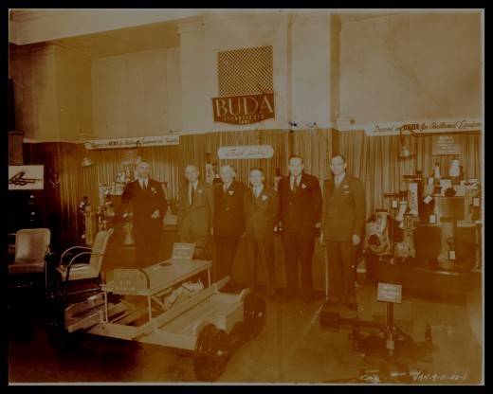

**T**he most basic scissor jack design is truly engineering at its finest. With the power to magnify input forces. A screw jack is a portable device consisting of a screw mechanism used to raise or lower the load. The principle on which the screw jack works is similar to that of an inclined plane. A **Scissor lifting** **Machine** used ***screw jack*** mechanism that converts [rotational](https://en.wikipedia.org/wiki/Rotation) motion to [linear motion](https://en.wikipedia.org/wiki/Linear_motion), and a [torque](https://en.wikipedia.org/wiki/Torque) (rotational force) to a linear [force](https://en.wikipedia.org/wiki/Force).

​

Great Grandfather Frank L. Gormley (3rd from the left in dark suit)

**OBJECTIVE**

**T**he performance goals of our aim to make this project valuable to our College ELITE POLYTECHNIC INSTITUTE including our Mechanical Department. This **Scissor lifting Machine** can be used for lifting any heavy things. It has strong wheels, so it can be move well with limited load. This kind of machine help us to gather knowledge about the link motion and mechanism. The moment of the arm helps us to gather knowledge about degree of freedom of the link motion.

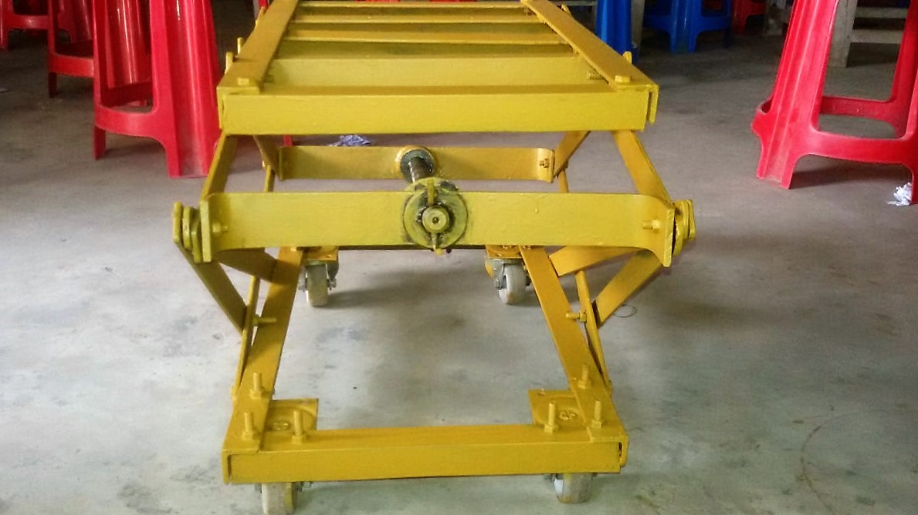

**THEORY**

**A** **scissor lift (jack)** or mechanism is device used to extend or position a platform by mechanical means. The terms "Scissor" comes from the mechanism utilized which is configured with linked, folding supports in a crisscross 'X' pattern. The extension or displacement motion is achieved applying of force to one of the supports resulting and an elongation of the crossing pattern.

**T**he force applied to extend the scissor mechanism may be hydraulic, pneumatic or mechanical (via a lead screw or rack and pinion system).

**Design Equations for Scissor Lift:**

**F**or a **scissor lift** that has straight, equal-length arms, i.e. the distance from the horizontal-jack-screw attachment (or horizontal hydraulic-ram attachment) point to the scissors-joint is the same as the distance from that scissor-joint to the top load platform attachment.

**Scissor Jack - Loading Applied at Bottom**

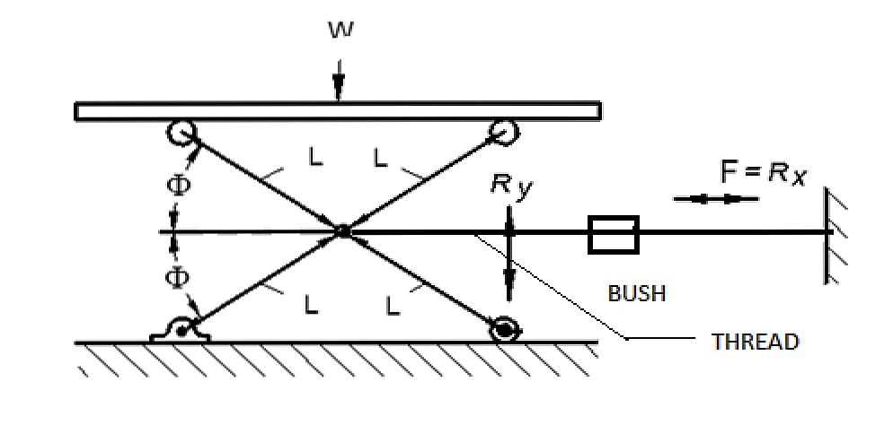

**Scissor Jack Equation With Load Applied At Center Pin:**  
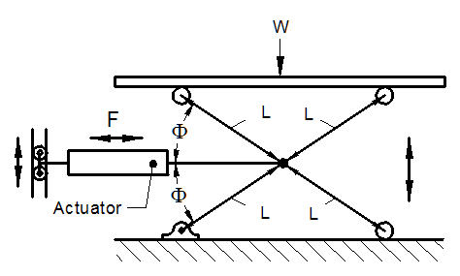

**Mechanical advantage:-**

**T**he [mechanical advantage](https://en.wikipedia.org/wiki/Mechanical_advantage) of a screw jack, the ratio of the force the jack exerts on the load to the input force on the lever, ignoring [friction](https://en.wikipedia.org/wiki/Friction) is

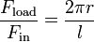

Where

 is the force the jack exerts on the load

 is the rotational force exerted on the handle of the jack

 is the length of the jack handle, from the screw axis to where the force is applied

* is the [lead](https://en.wikipedia.org/wiki/Lead_(engineering)) of the screw.

This derives from two factors, the simple lever advantage of a long operating handle and also the advantage of the [inclined plane](https://en.wikipedia.org/wiki/Inclined_plane) of the leadscrew. However, most screw jacks have large amounts of friction which increase the input force necessary, so the actual mechanical advantage is often only 30% to 50% of this figure.

**PROJECT DRAWING**

**Free Body Diagrams:**

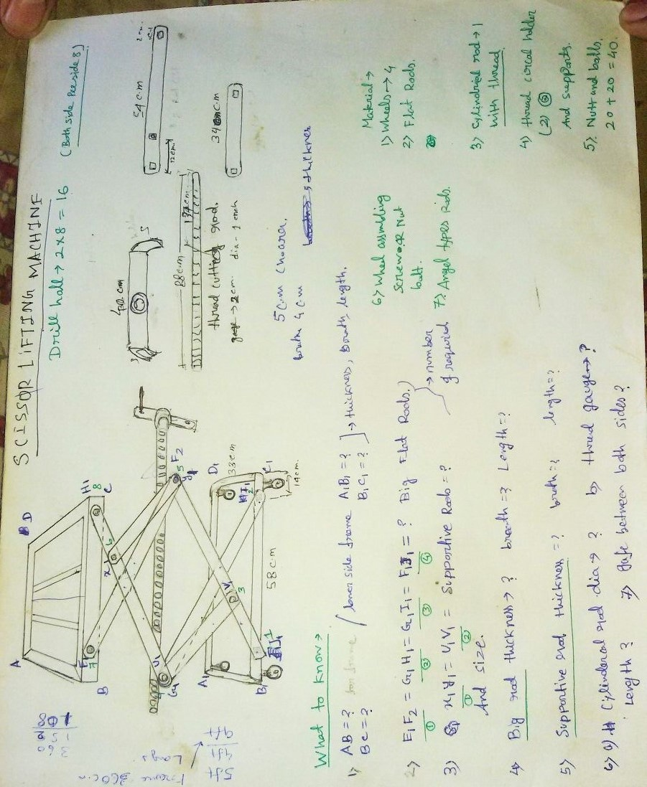

**PROCEDURE**

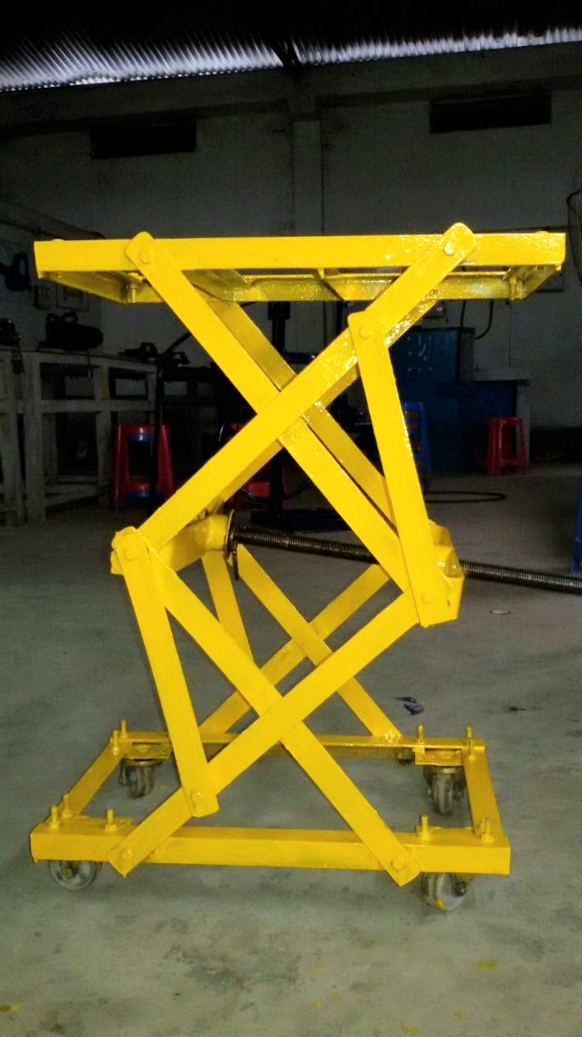

* First of all we choose the suitable

Material for our project, having collected the material of project work, we started to draw the design of the project.

* Being finalized our group members cut the materials according to desired shape of the design.
* Next, the cute materials structured and constructed by the nuts and bolts.
* After assemble of criss-croos structure, ( ) we started making the upper and lower frame.
* We used four angles plates for each frames to build the frame strong which help to support the arms and hold the frame vertically.
* Next we welded three extra angle plates with the upper frame, which helps to hold the loads of heavy goods more gently.

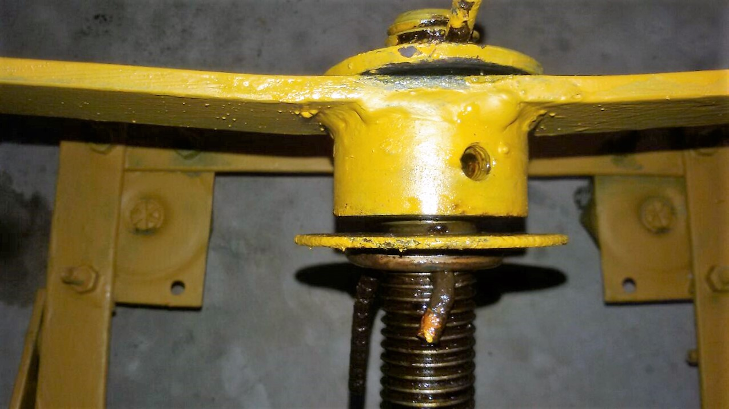

* After that one MS rod is threaded of V-cut with the help of die. Which is actually the main part of the machine.
* Then we have taken the same dimension and make another thread in a bush. Which we had already brought from market.
* When the project was in working progress, the machine got heavy, so we added four nylon trolley wheels to avoid the transportation problem.

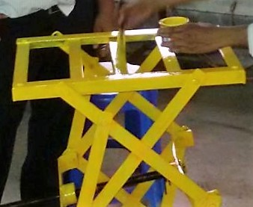

* Next we had taken the MS rod and two heavy flat plates (which we were cut in proper dimensions.) to Assemble in the middle of the machine.
* Then we made a handle with the flat metals, which helps us to operate the machine easily.
* Before we go for paint, we checked the total assembled machine, and fix the bugs and technical problems like ( plates to plate friction, looseness of nuts – bolts e.t.c )
* Then we painted the project with primer colour twice.
* After painted with primer we painted the project with permanent colour.
* After completed painting, we again checked the project properly & lubricating the project.

**APLICATION**

* This type of lifting machine used in mega factories to raise or down any kind of heavy goods.
* It have nylon trolley wheels, so it can be moved in any place where with heavy loads.
* Scissor lifting machine is hand operated device, it’s transform rotary motion into linear motion.
* The jack can be raised and lowered with a metal bar that is inserted into the jack. The operator turns the bar with his hands in a clockwise direction. This turns the screw inside the jack and makes it go up.

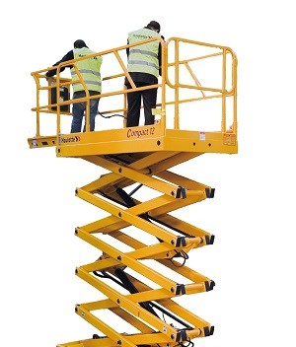

**ADVANTAGES**

* Easy to operate.
* It’s not require large place for use, instead of stored in minimum area.
* Screw jack scissor lifter energy efficient.
* It’s accessible & can be customized easily.
* With a versatile nature, they are easily adaptable with different terrains and climates.
* It’s Pollution free.

**DISADVANTAGES**

* It’s not so advance.
* It’s also have some limitation.
* In this machinery, if any parts chocked, or damaged Then it’s can’t work properly.
* It’s always needed Lubricant, otherwise it will not work properly.

**MATERIAL USED**

  

* Angle Plates: - It’s used for making the upper & lower frame.

* Flat Plates: - It’s used for making the main structure, which actually hold the weight.
* Trolley Wheels: - It’s used for transport the machine one place to another.
* MS Rod : It’s used for making the screw jack ,( basically the heart of this machine)
* Nuts and Bolts: - It’s used for assemble the whole frames and structure.
* Washers: It’s used to make the distance between each plates for reducing the friction**.**

**MACHINE USED**







 

* Lath machine: - It’s used for cutting the thread for screw jack mechanism.
* Drilling Machine: - It’s used for drilling the plates, as we needed.
* Grinding Machine: - Grinding is used to finish work piece that must show high surface quality and high accuracy of shape and dimension.
* Welding machine (Arc): - It’s used for welding the metal plates.
* Metal cutting Machine: - It’s used for cutting the metal plates as required.

**TOOL USED**

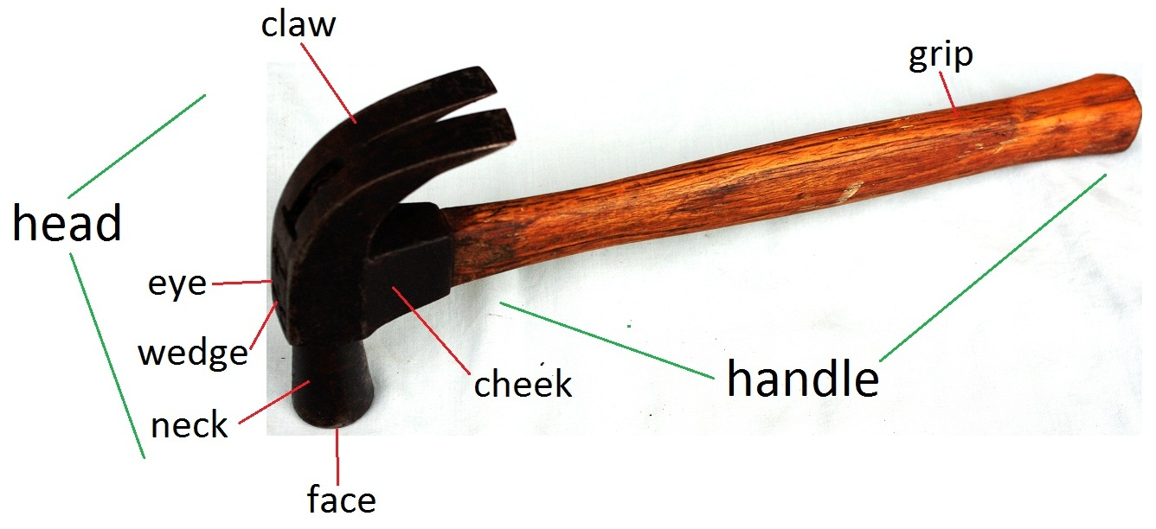

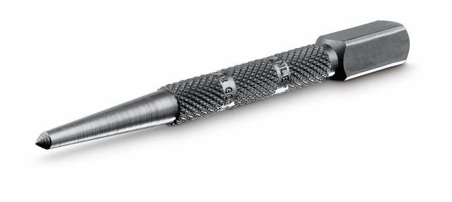

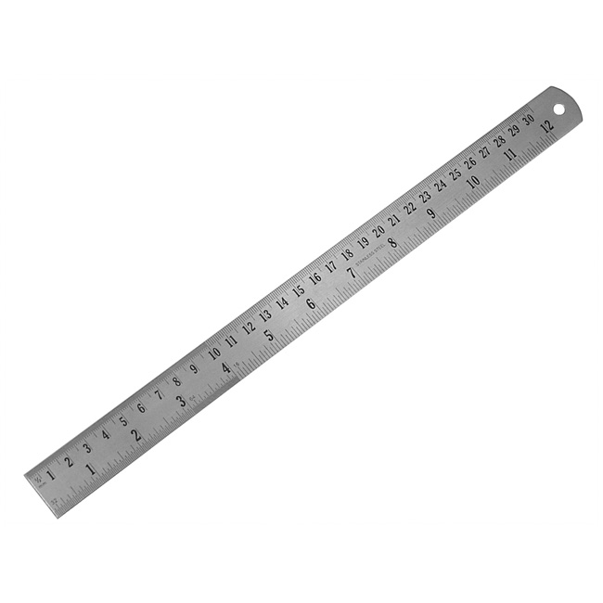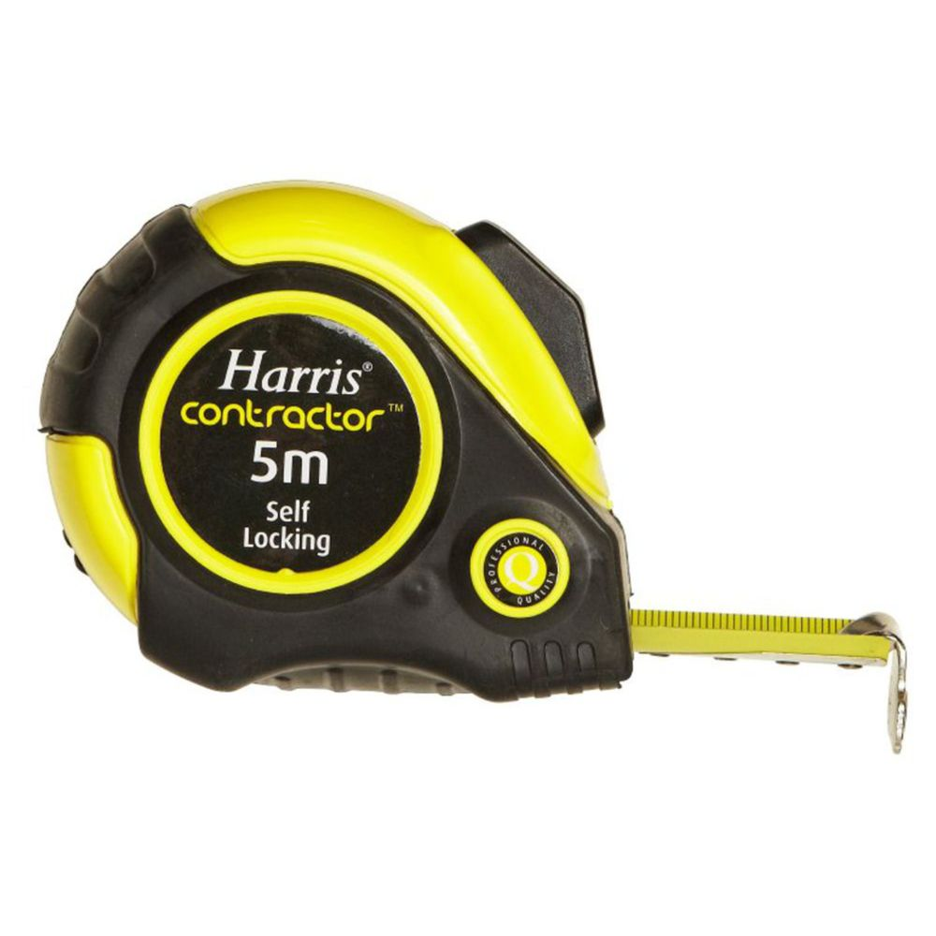

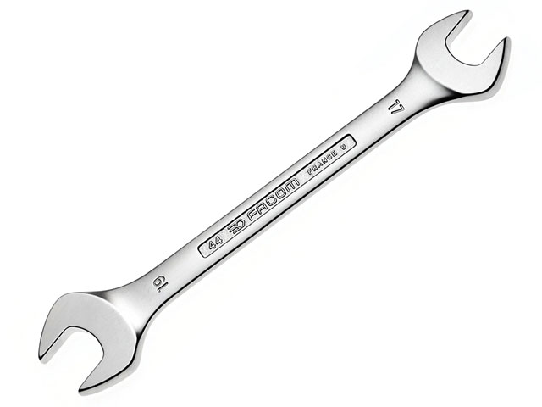

* HAMMER: - It is used for delivers a blow (a sudden impact) to an object.
* PUNTCH: - It is used to mark the center of a hole when drilling holes can be done.
* STEEL RULE: - It is used for measuring and marking.
* MEASURING TAPE: - Basically it’s used for measuring circular dimensions.
* SPANNERS: - It’s used to provide grip and mechanical advantage in applying torque to turn object- such as nuts & bolts.

**ESTIMATION**

Calculation of the approximate value of the result is called the estimation.

**COSTING**

The calculation of the actual cost of an article on the basis of different expenditures done to make it is called costing.

**PROBLEM FACED**

* Sometimes we can’t take the dimensions properly, so we faced the problem in assemble time.
* The plates attached with another plates and making huge frictions.
* The machine is heavy on it’s own weight. So we suffered with transportation problem.





**SOLUTIONS**

* We checked the dimension 3 times for make sure that all dimension are correct.
* We used washers to reduce the friction in the machine.
* We used the strong wheels for avoid the transportation problem.





**WASHERS**

**WHEELS**

**FUTURE SCOPE**

* If more time and more effort would have been put into the model, more complexities could have been brought out.
* Moreover instead of manual operation of syringes could have been replaced by-defined computer programs or merely by pressing the switch operated.
* Future, more varieties and more flexibility to add or replace any part according to requirements can be done to improve it use and increase filed of usage and to make it more universal or flexible.
* It can be upgraded with pneumatic system, hydraulics mechanisms.
* In future the scissor lifter will be the most comfortable transportations system for goods carrying in industry.

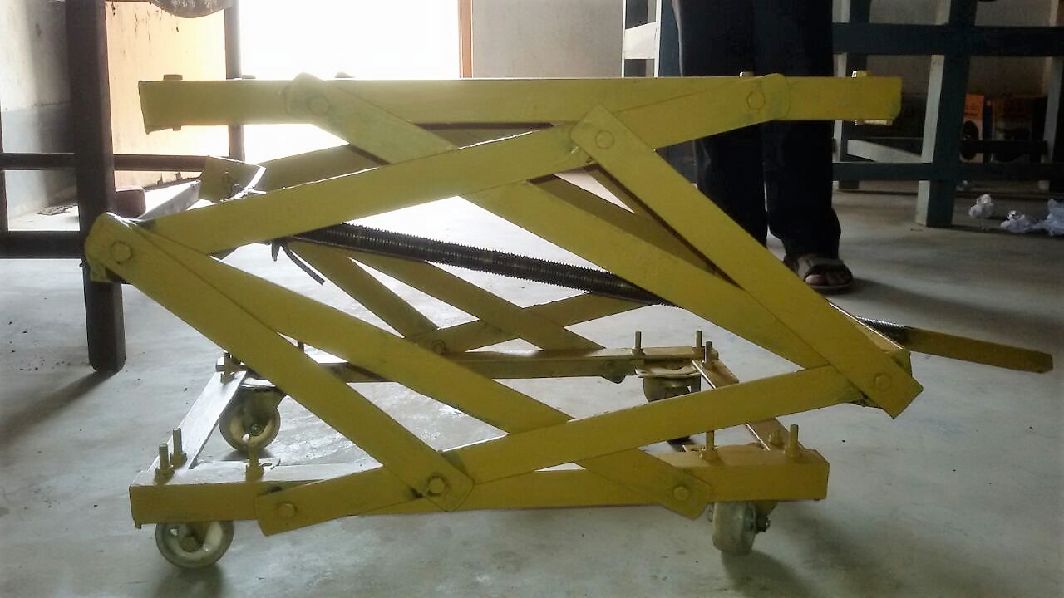

**CONCLUSION**



**CONCLUSION**

* This was the wonderful experience for us to participate in a group work for a project.
* The prepared mechanism has been successfully constrained and executed to carry out the required work of picking up the weight of objects.
* It was a great opportunity for us learn how to work in a team, face problem, find solution, and implement a project. Adobe all we got the spirit of team work.
* But without help our teachers we will not able to implement it. THANKS to all of our Teachers.

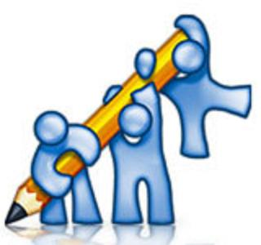

**REFERNCE**

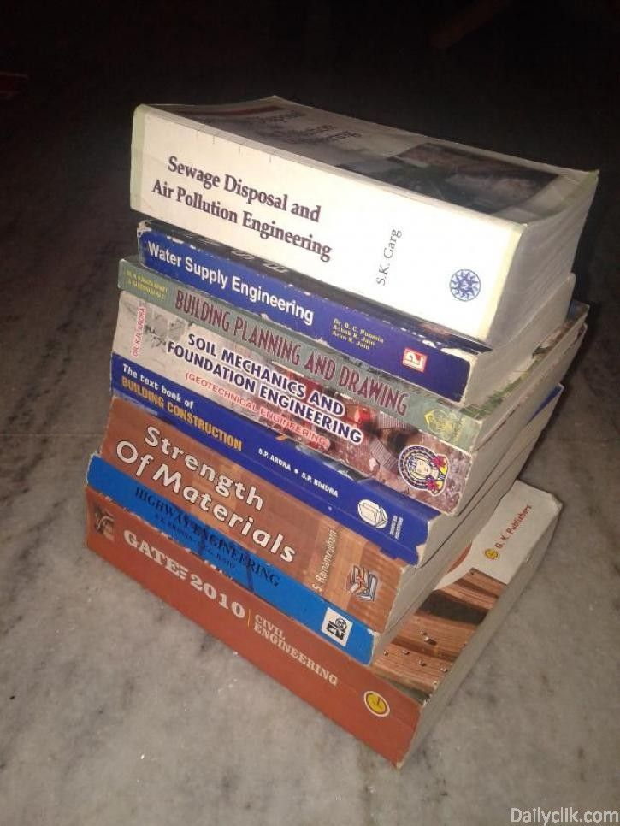

A text book of Machine Design by R.S.Khurmi,J.K.Gupta.

Design of machine elements by V.B.Bhandari.

Design of machine elements by K.Rao.

Design of Machine Elements by Faradak Haideri.

Machine Design by S.G.Kulkarni.

http://en.wikipedia.org/wiki/Jack_(device).

http://hubpages.com/hub/Automobile-Jacks.

http://www.powerjacks-de.com/Screw-Jacks-FAQ.html.

<http://www.radicon.com/screw-jacks.php>.

http://www.powerjacks.com/PowerJacks-History-The-crew-Jack-Story.php.

